# WATER AUTOMATION

**Submitted by Dangar Jatin R. 179830307006**

#### Guided by

**NANDAN PANDYA**

##### Lecturer, Kalyan Polytechnic

Jamnagar

**Report Submitted to Gujarat Technological University**

In Partial Fulfillment of the Requirements

**For the Degree of Diploma Engineering in Computer Science & Engineering** August –2019



Kalyan Polytechnic Aliabada Road, Jambuda Chowkdi,

Jamnagar, Gujarat-361120

Water Automation 179830307006



# CERTIFICATE

This is to certify that the work embodied in this Thesis entitled. WATER MANAGEMENT SYSYTEM was carried out by DNAGAR JATIN R *(179830307006)* in Computer Science & Engineering Department of Kalyan Polytechnic, Jamnagar for Partial Fulfillment of Degree of Diploma Engineering in Computer Science & Engineering to be awarded by Gujarat Technological University. This Research work has been carried out under my supervision and is to my satisfaction.

#### Date:

**Place**: JAMNAGAR

###### Signature of Guide: Signature of Principal: Signature of H.O.D:

**Prof.**

**Assistant Professor**

Kalyan Polytechnic, Jamnagar

###### Dr. Principal

Kalyan Polytechnic, Jamnagar

###### Prof.

**Head of Department**

Kalyan Polytechnic, Jamnagar

#### Seal of Institute

|  |  |  |  |  |
| --- | --- | --- | --- | --- |
| **Table of contents** | | | | |
|  | **Acknowledgement** | | | **I** |
| **Chapter: 1** | **INTRODUCTION** | | | 5 |
|  | 1.1 Summary | | |  |
|  |  | 1.1.1 Definition | |  |
|  |  | 1.1.2 Introduction | |  |
|  | 1.2 | Purpose | |  |
|  | 1.3 | Scope | |  |
|  | 1.4 | Objective | |  |
|  | 1.5 | Technology | | 9 |
| **Chapter: 2** | **PROJECT MANAGEMENT** | | |  |
|  | 2.1 Project Planning | | |  |
|  |  | 2.1.1 Project Development Approach | |  |
| **Chapter: 3** | **SYSTEM REQUIRMENT STUDY** | | | 11 |
|  | 3.1 | Hardware and Software Requirements | |  |
|  |  | 3.1.1 Hardware Requirement and Selection | |  |
|  |  | 3.1.2 Software Requirement and Selection | |  |
|  | | | | |
| **Chapter: 4** | **SYSTEM ANALYSIS** | | | 14 |
|  | 4.1 | Exiting System | |  |
|  | 4.2 | Proposed System | |  |
|  | 4.3 | Features of New System | |  |
| **Chapter: 5** | **SYSTEM DESIGN** | | | 18 |
|  | 5.1 | Class Design | |  |
|  | 5.2 | Activity Diagram | |  |
|  | 5.3 | Use-Case Diagram | |  |
|  | 5.4 | Sequence Diagram | |  |
|  | 5.5 | Data flow | |  |
| **Chapter: 6** | **IMAGAES THAT USED IN YHIS PROJECT** | | 25 | |
| **Chapter: 7** | **LIMITATION AND FUTURE ENHANSMENTS** | | | 28 |
|  | 7.1 | Limitations | |  |
|  | 7.2 | Future Enhancement | |  |
| **Chapter: 8** | **CONCLUSION** | | | 30 |
|  | 8.1 | Problem Encountered and Possible Solution | |  |
|  |  | 8.1.1 To get Knowledge of Technology | |  |
|  |  | 8.2.1 Requirement Understanding | |  |
|  | 8.2 | Summary of Project Work | |  |
| **Chapter: 9** | **BIBLIOGRAPHY** | | | 31 |
|  | | | | |

**ACKNOWLEDGMENT**

Presentation of this report gives me the feeling of fulfilment. As the final frontier towards achieving CSE., the activity of going through industrial orientation has bridged the gap between the academics and practical real-life work for us to apply ourselves better to become a good computer professional naturally, if require a lot of people support to complete this training. We take the opportunity to acknowledge their support to us.

We specially Thanks To Our College Faculty NANDAN PANDYA, KAUSHIK H. RAVIYA to Good Support to made our project. We sincerely thank us Department for academic Advancement the who has provided us during the last three year and finally provide us an opportunity for project work. We thank head of computer technology department of Gujrat Technology University. Also, we want to thanks authority and all staff members of Kalyan polytechnic College, for guiding us in the work that we have done. And finally, our sincere thanks to your batchmates, who have provided us with innumerable discussion on many friendly tips. Without them cordial and finally support, this activity would

***-Dangar Jatin R.***

# INTRODUCTION

#### SUMMARY

###### Definition

This project is about water management, now a day’s lots of water is wasted annually, to overcome this problem we decided to make this work automatic now in this Modern world it is possible to make this using new technology

#### Introduction

Now the idea was to on/off motor automatic without any human help , it use hardware & software to make this project it generally turns off the motor when the tank is full and turn on when the tank is empty, We know many times forget to turn off the water motor and very large amount of water is wasted, After using this project we can turn of motor automatic according to our need.

We also get alert & update message to mobile via the use of internet we use Arduino, water sensor, wi-fi module, java.

#### PURPOSE

* This project overcomes the problem of water wasted.
* This project saves electricity bill by automatically turning off the motor.
* This project tells you and turn off the motor when the tank is full.
* This project tells you and turn on the motor when the tank is empty.
* This can operate anywhere by using an internet connection (future part).
* This project saves lots of water annually.
* This project prevents the tank to overflow & empty.
* This project saves time and money by its automation technology.
* This project sends updates to mobile (future part).
  1. **SCOPE**

##### This project very useful in now a day we many times forget to turn off the motor and many times we also burnt the motor.

* This project helps you to save two major things that electricity and water.
* This project helps us to control motor form anywhere form this world.
  1. **OBJECTIVE**

**The objectives of the development are:**

* Integration of motor automation.
* Computerization of motor automation which save time, electricityandwater

###### Project Goals

* + To build a prototype of WMS (Water Management System).
  + Reduce complexity of water management.
  + To provide an electronic version for water management system.
  + System will have a user-friendly graphical representation.

**Benefits**

* This project overcomes the problem of water Wasted.
* This project saves electricity bill by automatically turning off the motor.
* This project tells you and turn off the motor when the tank is full.
* This project tells you and turn on the motor when the tank is empty.
* This can operate anywhere by using an internet connection (future part).
* This project saves lots of water annually.
* This project prevents the tank to overflow & empty.
* This project saves time and money by its automation technology.
* This project sends updates to mobile (future part).

### TECHNOLOGY AND LITERATURE REVIEW

#### What is C++?

* C++ is a general-purpose programming language and widely used now a days for competitive programming. It has imperative, object-oriented and generic programming features. C++ runs on lots of platform like Windows, Linux, Unix, Mac etc.
* C++ is considered to be an intermediate-level language, as it encapsulates both high- and low- level language features. Initially, the language was called "C with classes" as it had all the properties of the C language with an additional concept of "classes." However, it was renamed C++ in 1983.
* The ide software is used to write the code.

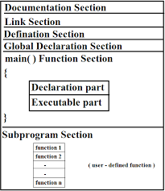

#### Structure of C++

There are manly six section of c++ structure

* Documentation
* section Link section
* Definition section
* Global declaration
* Main function section
* Sub program

#### Sections of C++

1. **Documentation section- Documentation** section is where comments about what the underlying code are written. It is not mandatory to include a documentation section but, including one help programmers and users understand the program code easily. Comments are not compiled by compiler

i.e. they are ignored. So, they don't have any syntax and we can write anything in the comment section. Usually in large programs with thousands of lines of codes, comments are used to minimize confusion and increase readability.

1. **Link section**- Link section is where header files required for the program are included. Header files consists of function prototypes and on program execution, these files are placed on to the file by the pre-processor. They may be predefined like iostream, string, math, etc or user-defined.

##### **Declaration section-** In this section, classes used in the program are declared and/or defined. Body of class is enclosed by curly brackets and ends with a semicolon. Class consists of attributes and functions which are the members of that class

1. **Sub program-** In this section, classes used in the program are declared and / or defined. Body of class is enclosed by curly brackets and ends with a semicolon. Class consists of attributes and functions which are the members of that class
   1. **PROJECT MANAGEMENT**

#### 2.1 PROJECT PLANNING

###### 2.1.1 Project Development Approach

For designing a software, we decide to follow the Software Development Life Cycle. Software Development Life Cycle (SDLC) was introduced to address the problems faced during the software development process. SDLC is a disciplined and systematic approach that divides the software development process into various phases, such as requirement, design, and coding. The phase-wise development process helps to track schedule, cost, and quality of the software projects life cycle.

###### Phases of SDLC

1. **Feasibility analysis**

Includes analysis of project requirements in terms of input data and desired output, processing required to transform input into output, cost-benefit analysis, and schedule of the project. The feasibility analysis also includes the technical feasibility of a project in terms of available software tools, hardware, and skilled software professionals. At the end of this phase, a feasibility report for the entire project is created.

###### Requirement analysis and specification

Includes gathering, analyzing, validating, and specifying requirements. At the end of this phase, the Software Requirement Specification (SRS) document is prepared. SRS is a formal document that acts as a written agreement between the development team and the customer. SRS acts as input to the design phase and includes functional, performance, software, hardware, and network requirements of the project.

###### Design

Includes translation of the requirements specified in the SRS into a logical structure that can be implemented in a programming language. The output of the design phase is a design document that acts as an input for all the subsequent SDLC phases.

###### Coding or Implementation

Includes implementation of the design specified in the design document into executable programming language code. The output of the coding phase is the source code for the software that acts as input to the testing and maintenance phase.

###### Testing or Verification

Includes detection of errors in the software. The testing process starts with a test plan that recognizes test- related activities, such as test case generation, testing criteria, and resource allocation for testing. The code is tested and mapped against the design document created in the design phase. The output of the testing phase is a test report containing errors that occurred while testing the application.

###### Maintenance

Includes implementation of changes that software might undergo over a period of time, or implementation of new requirements after the software is deployed at the customer location. The maintenance phase also includes handling the residual errors that may exist in the software even after the testing phase.

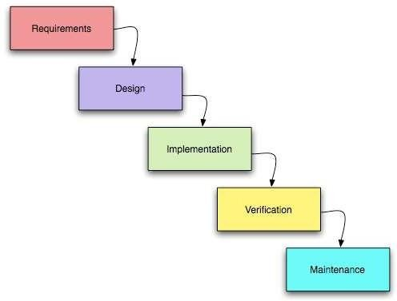

**Fig.2 Phases of SDLC**

.

## SYSTEMS REQUIREMENTS STUDY

System requirements study involves a clear and thorough understanding of the product to be developed with the view of removing all ambiguities from customer perception. This is our first version specific requirement, since our client gives us different goals as time goes by according to their preferences.

#### HARDWARE SOFTWARE REQUIREMENTS

###### Hardware Requirement

* Arduino UNO
* ULTRA-SONIC SENSOR
* 16*2 LCD Display
* 5V Relay
* Piezo Buzzer
* Push Button
* LEDs
* Resistors
* 3P PCB Screw Terminal Block Connector
* Female Pin Header Connector Strip
* Male Pin Header Connector Strip
* 5V relay board(optional)
* Jumper wire.

###### Software Requirements

* + - * ARDUION IDE software for programing

## ARDUINO UNO

Arduino is the brain of this project. It will take input from the sensors and control all other units according to the value received.

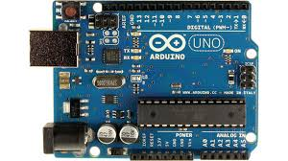

### LCD

The second block is 16x2 LCD display. This unit will display the Water Level in percentage as well as in

Bar Diagram, it will also show the Pump status. This section will also notify us whenever the Sump tank is empty

* TANK IS EMPTY / TANK IS FULL
* WATER LEVEL =100% / WATER LEVEL =50%
* MOTOR IS ON / MOTOR IS OFF

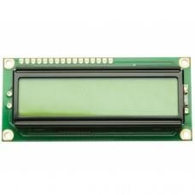

### SONAR SENSOR

The Sonar Sensor. This is used to measure the water level present on the overhead water tank Let's understand the working principle of the Sonar sensor.

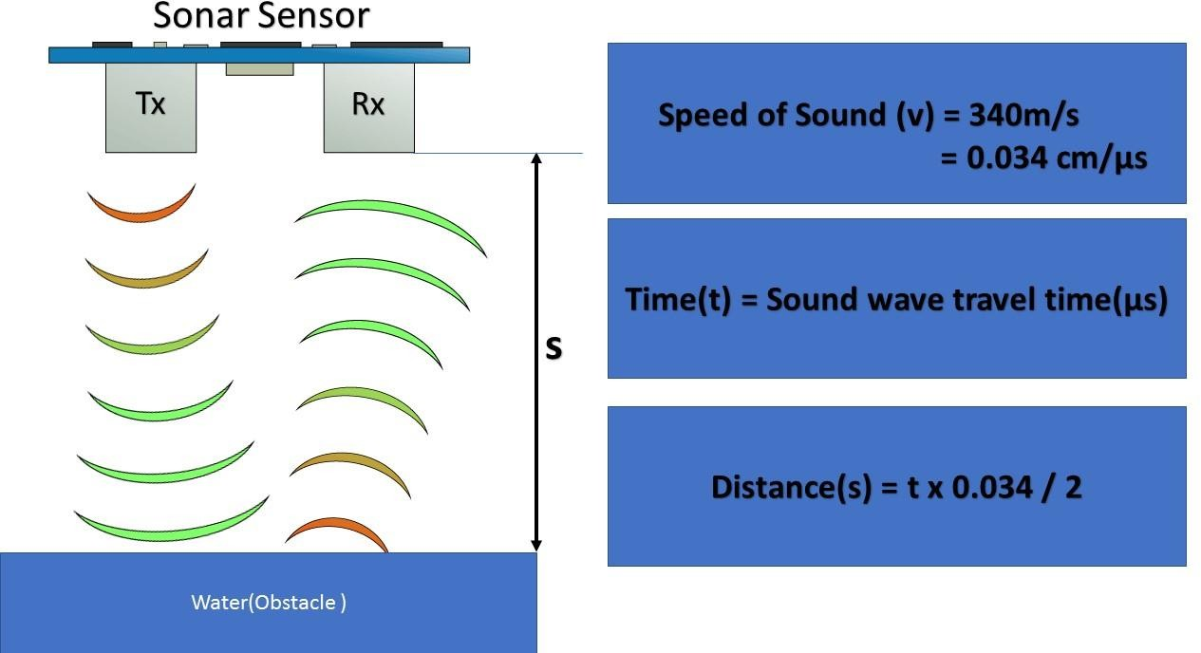

Sonar Sensor emits an ultrasound at 40 kilohertz, which travels through the air, and if there is an object or obstacle on its path, it will bounce back to the module Arduino will use the echo pin, present on Ultrasonic sensor

to measure sound wave travel time in microseconds Considering the travel time and the speed of the sound, you can calculate the distance using the formula shown here

#### 5V RELAY

This provides as constant 5v for external sensor and it help us to prevent any kind short circuit It converts 12v DC to 5V DC

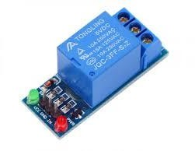

### PIEZO BUZZER

The Buzzer, this is used to notify when the sump tank is empty.

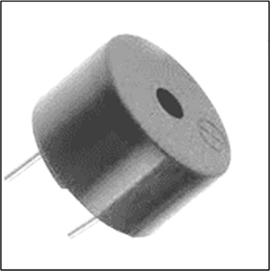

### PUSH BUTTON

The push button, this is used to measure the Tank height at the time of installation of this Circuit. This can further used if you wish to replace the water tank with a new one.

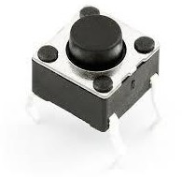

# SYSTEM ANALYSIS

###### EXISTING SYSTEM

* + - If a person wants to check the water level, he uses to follow one of these things:
    - Manually goes to the tank and check.
    - The manually result was not accurate.
    - Nearly impossible for old age person to check the water level.
  1. **PROPOSED SYSTEM**
     + The Proposed system ensures the completely done water automation, where user doesn’t need to check water level.
     + In this Proposal the entire work is done on automatic
  2. **REQUIREMENTS OF NEW SYSTEM**

###### User Requirements:

User requirement specifies requirement of the user of the system. The user requirements are:

* + - * User can check the water level without any effort
      * User doesn’t start the motor the task done automatic

###### System Requirements:

* + - * Hardware like sensors, connector & relays
  1. **FEASIBILITY STUDY**

Feasibility study is an important phase in the software development process. It enables the developer to have an assessment of the product being developed. It refers to the study of the likelihood of the product in terms of outcomes of the product, operational use and technical support required for implementing it. It is both necessary and prudent to evaluate the feasibility of a project at the earliest possible time.

Feasibility study should be performed on basis of various criteria and parameters. The various Feasibility studies are:

* + - Economic Feasibility
    - Technical Feasibility
    - Operational Feasibility

Feasibility study is to check the viability of the project under consideration. Theoretically various types of feasibilities are conducted, but we have conducted three type of feasibilities explained asunder.

###### Economic Feasibility:

* + Current instrument which has used in this project is cost efficient
  + With the manual system the operating cost of the system is about 60 Lacks P.A. This cost comprises salary of 25 people, stationary, building rent, electricity, water, telephone etc. But with the new system this reoccurring cost comes out to be about 20 Lakes P.A. Hence the new system is economically feasible.

###### Technical Feasibility:

* All the instrument gets connected easily and work in single ways as the system gives the command.
* The new system requires only 6 trained people to work with the system and in overall 10 people per office are sufficient. So, we will identify 6 best people from existing system and train them. As our existing system is purely manual, so we need a time investment of Rs 4 Lakes for the purchase of 7 computers, 5 Ticket printers, a laser printer, AC and networking etc. It requires 20Lacks PA as an operating cost. With the above details our system is technically feasible as after investing 24 Lacks in a year, the company is still saving Rs 25 Lacks PA.

###### Operational Feasibility:

* This project can work with the existing system easily with out any kind of changes to system.
* The new system requires only 6 trained people to work with the system and in overall 10 people per office are sufficient. So, we will identify 6 best people from existing system and train them. As our existing system is purely manual, so we need a time investment of Rs 4 Lakes for the purchase of 7 computers, 5 Ticket printers, a laser printer, AC and networking etc. It requires 20Lacks PA as an operating cost. With the above details our system is technically feasible as after investing 24 Lacks in a year, the company is still saving Rs 25 Lacks PA.

#### REQUIREMENT VALIDATION

* + - A requirements validation is concerned with showing that the requirements actually define the system, which the customer wants.
    - Requirements validation is important because errors in a requirements document can lead to extensive rework costs when they are subsequently discovered.

###### Requirement Validation Checks

We have done below validation checks

**Validity checks –** Check whether the water level information comes is true

**Consistency checks –** Requirements in an information is not conflicting.

**Completeness checks –** The requirements document includes requirement, which define all functions, and constraints intended by the system user.

**Realism checks –** Using knowledge of existing technology, the requirements are checked to ensure that they could actually be implemented.

**Verifiability –** The requirements are given in verifiable manner (e.g.: Using quantifiable measures) to reduce disputes between client and developer.

###### Requirement Validation Techniques

We have used following Validation Techniques

* **Requirement Review –** We analyzed the requirements systematically
* **Prototyping –** In this approach to validation, an executable model of the system is demonstrated to our clients. So, by doing this they can check whether the considered requirements satisfy their needs.
* **Test-case generation –** Requirements should ideally be testable. If a test is difficult or impossible to design, this usually means that the requirements will be difficult to implement and should be reconsider. We have found such requirements.
* **Automated consistency analysis –** if the requirements are expressed as a system model in a structured or formal notation than CASE tools may be used to check the consistency of the model.

Water Automation 179830307006

#### Features of New System

* + - if a person wants to check the water level, he uses to follow one of these things: Manually goes to the tank and check. The manually result was not accurate. Nearly impossible for old age person to check the water level.
    - After this project the whole process was done automatically, so the person not need to go and check the water level again and again

#### SELECTION OF HARDWARE & SOFTWARE AND JUSTIFICATION

###### Software Selection

**Table 4.1 Software Selection**

|  |  |
| --- | --- |
| **Developer Side:** | |
| **Operating System** | Windows 7 to  windows 10 |
| **Programming language** | C++ |
| **Development IDE** | ARDUION IDE |

* **Hardware Selection**

**Table 4.2 Hardware Selection**

|  |  |  |
| --- | --- | --- |
| **Client Side:** | **Processor** | **Other hardware** |
| Arduino Nano | sonar sensor , 16*2 lcd display , Piezo Buzzer, LED ,  5V Relay . |

# SYSTEM DESIGN

#### CLASS DIAGRAM

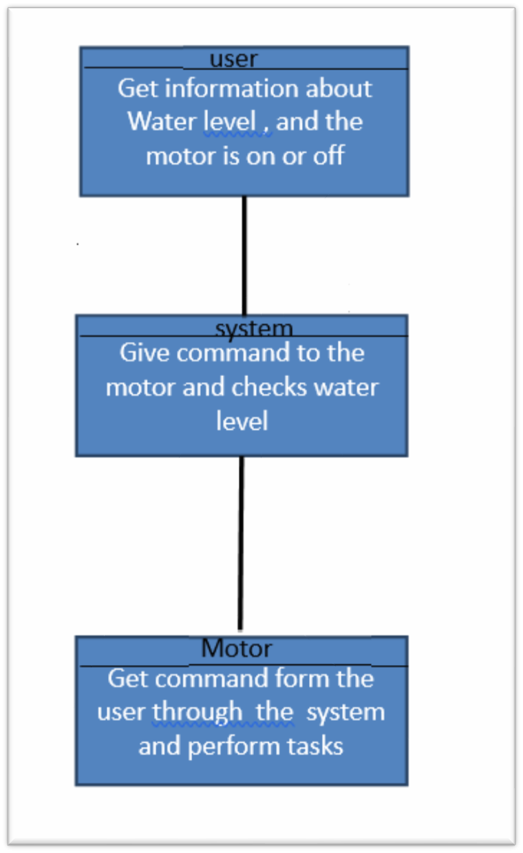8

#### ACTIVITY DIAGRAM

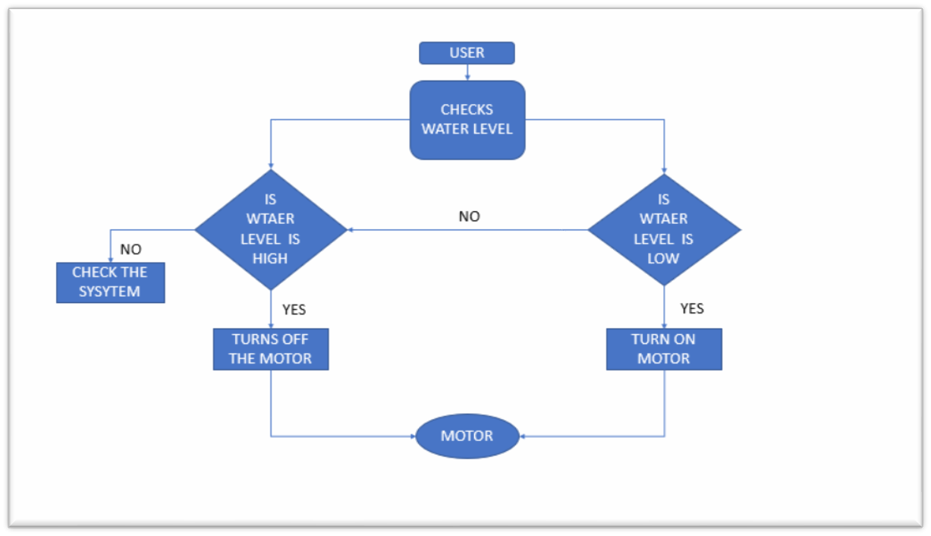

###### Use-case Diagram for User

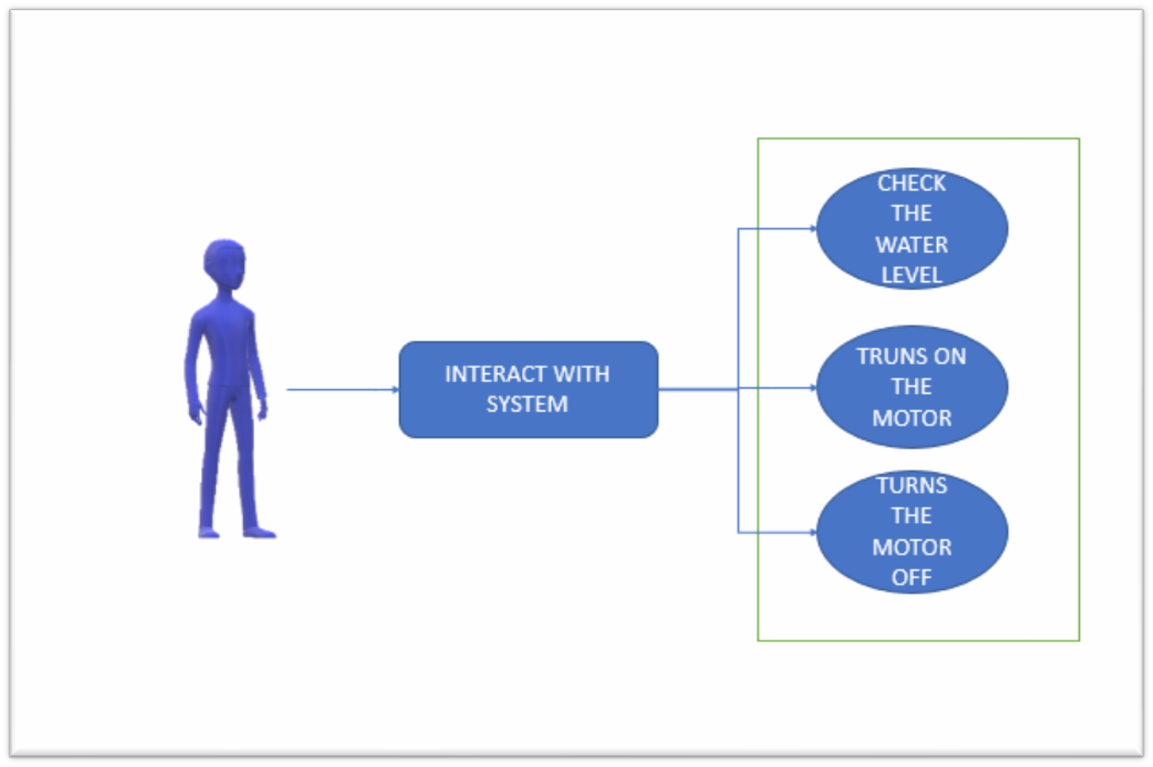

**5.5 SEQUENCE DIAGRAM**

**5.5.1 Sequence Diagram for Admin**

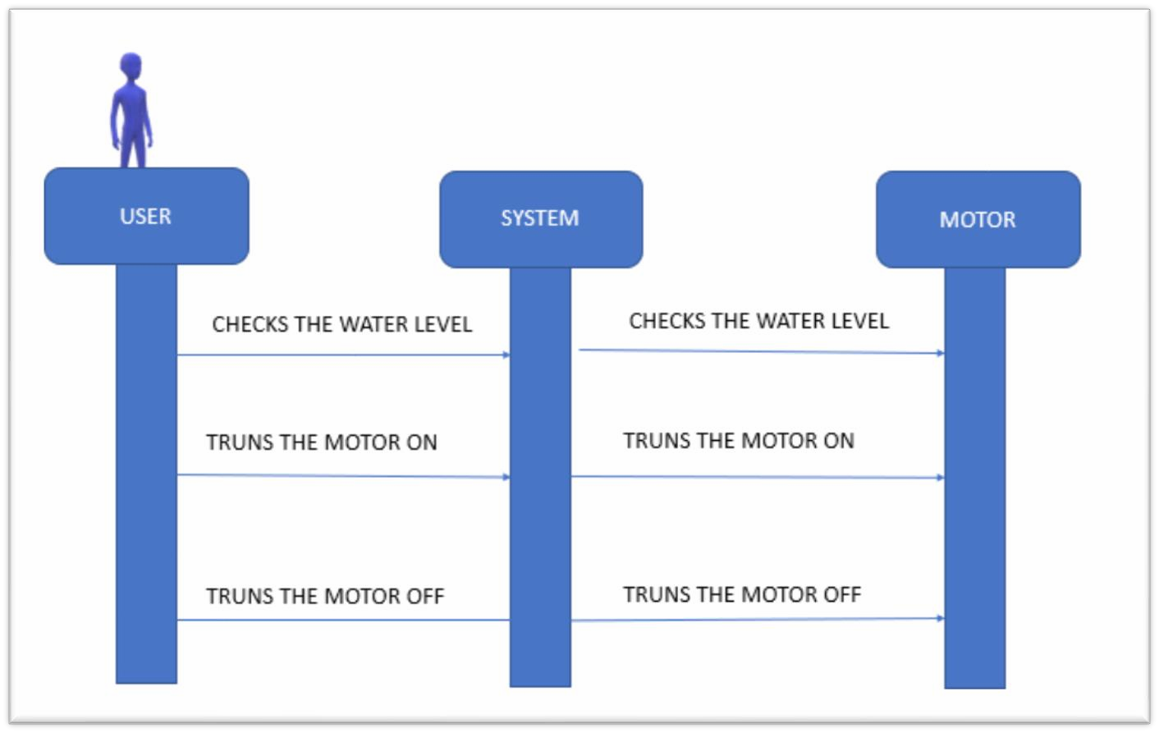

* 1. **FUNCTIONAL AND BEHAVIORAL MODELING**

**Context Diagram**

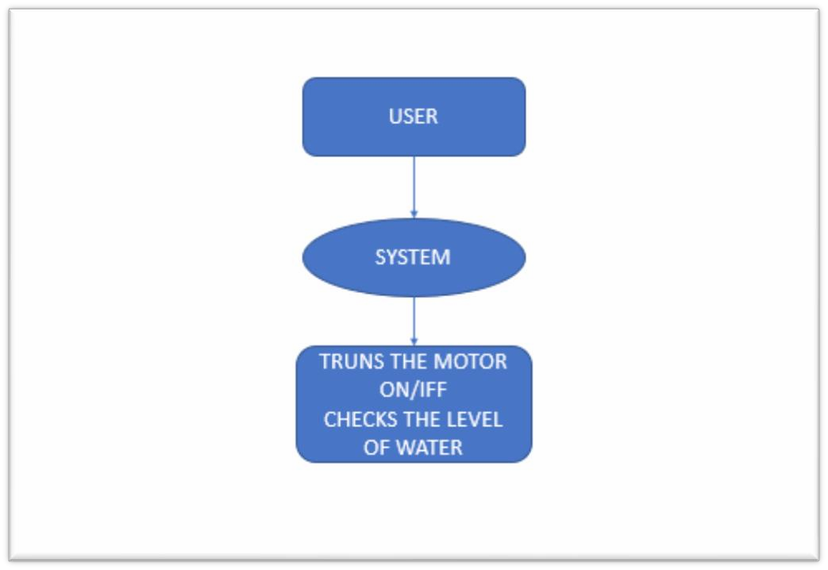

* 1. **Data Flow Diagram 5.6.1Logical 0 Level DFD**

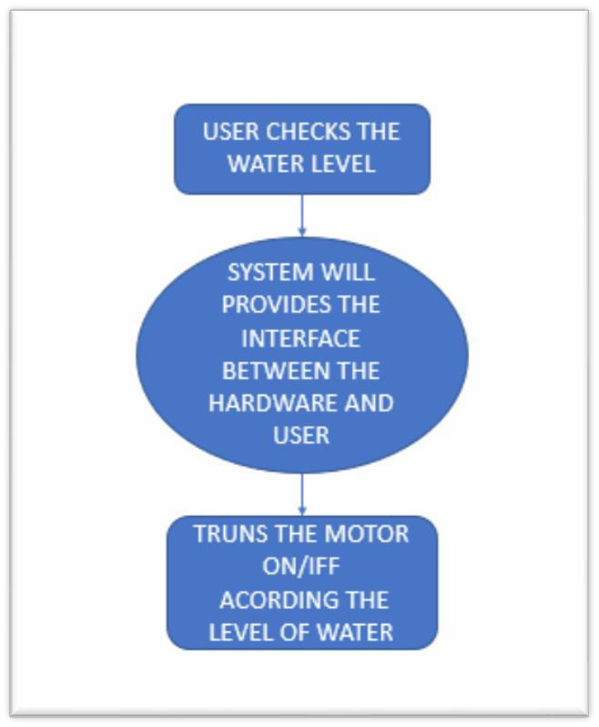

**5.6.2 PHYCICAL LEVEL 1 DFD**

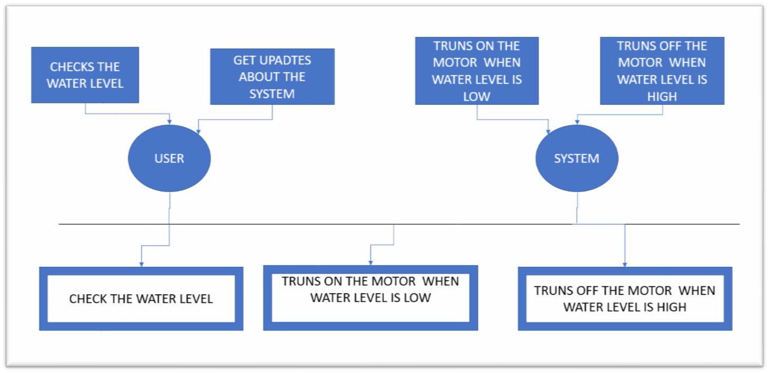

* 1. **PICTURES OF WORKING MODEL**

**6.1 IMAGES OF THINGS USED IN THIS PROJECT**

* **HARDWARE IMAGES**

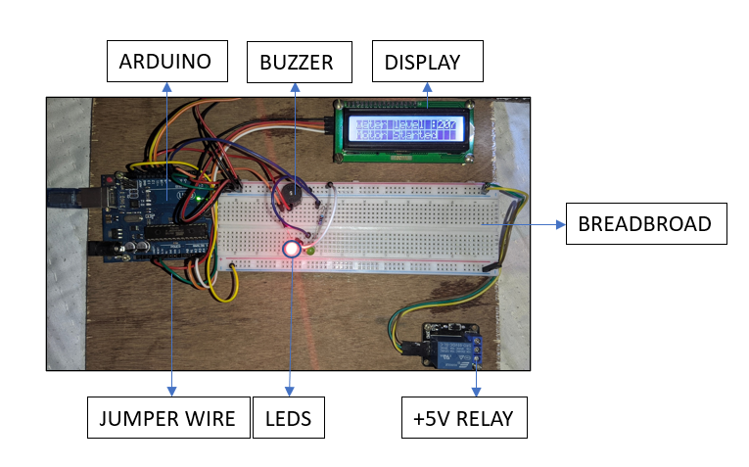

* **CIRCUIT DIAGRAM**

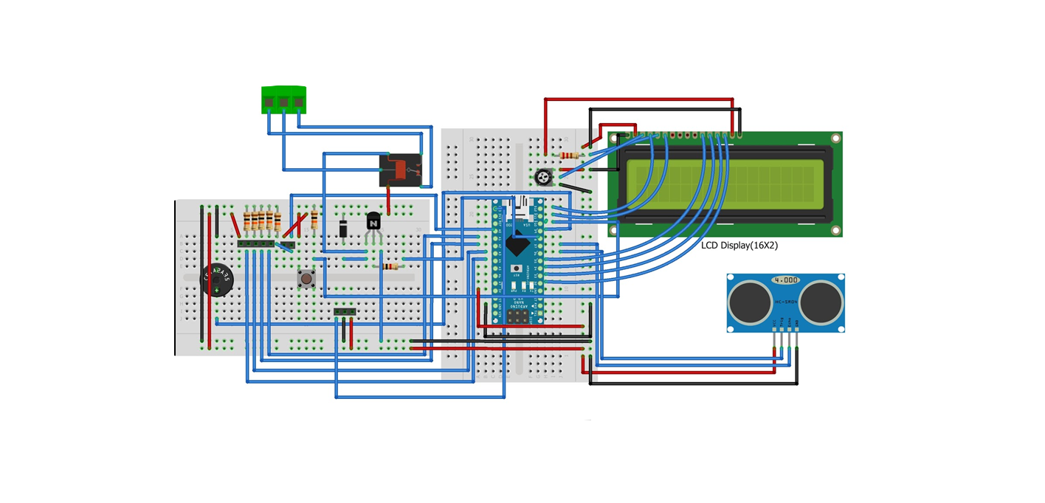

* **LEDS AND BUZZER FOR INDICATION**

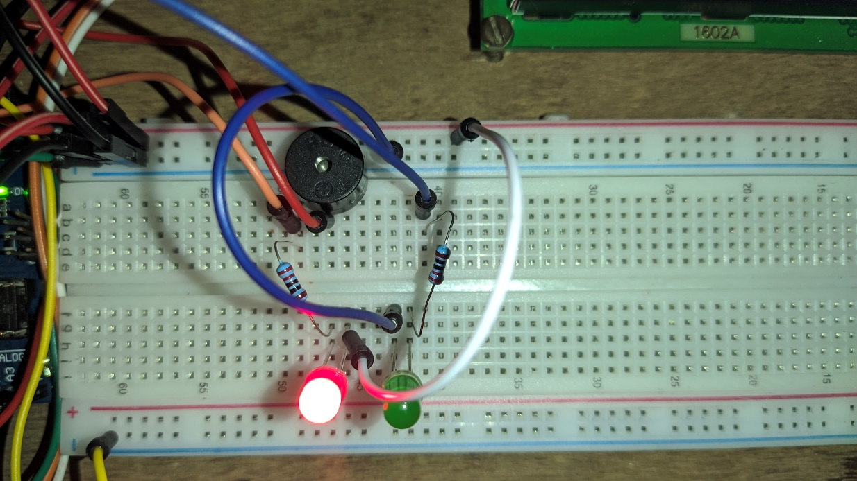

* **ARDUINO UNO MICROCONTROLLER**

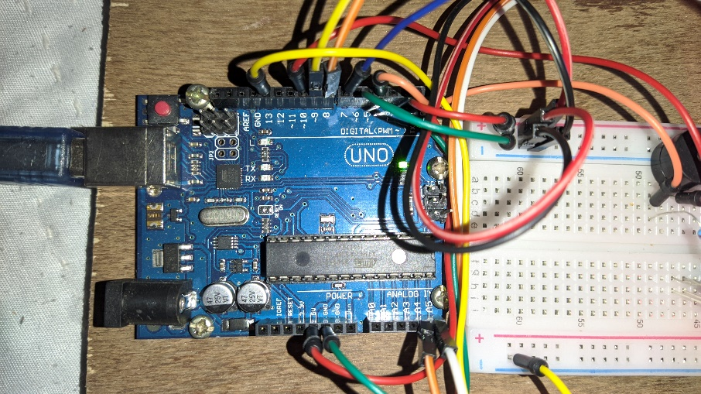

* **DISPLAY FOR OUTPUT**

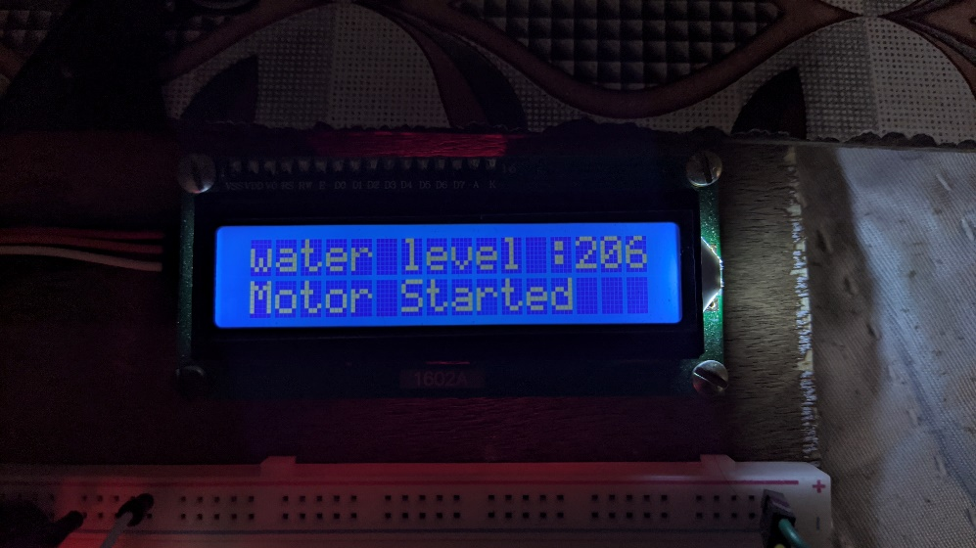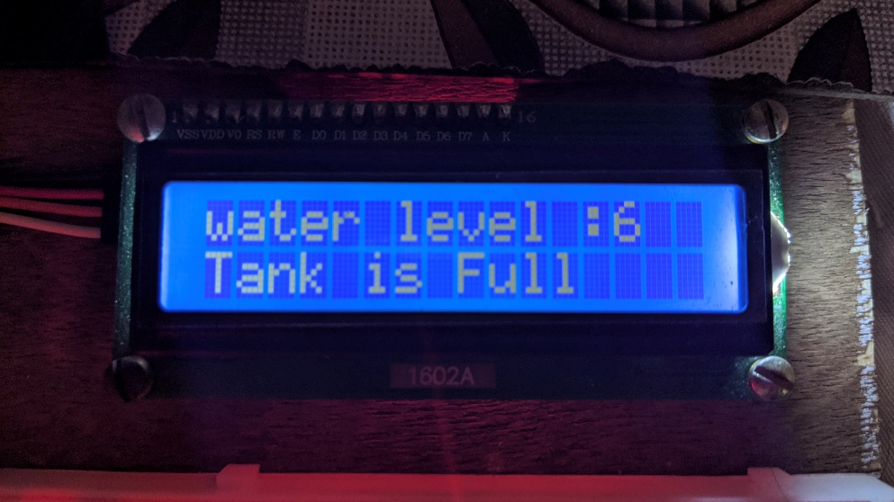

* **MOTOR**

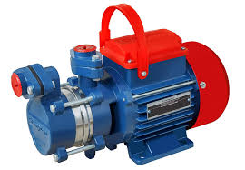

* 1. **LIMITATIONS AND FUTURE ENHANCEMENTS**

**7.1 Limitations**

Limitations are as follows:

* + 1. Electricity is must.
    2. One person can use whole system at a time.

There are many problems in existing systems like:

* Time and speed
* Man power
* Complexity
* Maintenance

#### Future Enhancements

We can add more modules to this project like updating water level information like tank is empty, motor is on, and gives you notification on your device. Getting accurate information about water level on your device live.

* 1. **CONCLUSION**

The project is about water automation this helps us to do all the task automatic without any human help, this check the water level the control the system as the water level.

#### 8..1 Problem Encountered and Possible Solution

###### To get the knowledge of Technology:

* + - * To develop the system, deep knowledge of C++ is required.

###### Requirement understanding:

* + - 1. Collected requirement were clear. All doubts were resolved after discussing it with our external guide.
      2. They provided the actual understanding of the client’s requirements from the system.

#### Summary of Project Work

We have planned our project work using the concept of the software engineering, and system analysis and design approach. Our first phase was the preliminary investigation in which we collected all the information related to our project with the help of Internet and project guide. In this phase, we made our minds clear about what we are going to develop. We have done the work with the pre-planning and scheduling related with time constraints.

## BIBLIOGRAPHY

#### REFERENCE WEBSITE

<https://www.arduino.cc/> <https://www.programtopia.net/cplusplus/docs/structure-and-sections>

<https://electronicsforu.com/resources/learn-electronics/16x2-lcd-pinout-diagram>

#### FACULTY

#### Nandan Pandya

#### Kaushik Raviya